# Site Flow and Sketches

## Step 1: Competitive Analysis

|  |  |
| --- | --- |
| Competitor Site 1: <visit Seattle> URL: < http://www.visitseattle.org/> AnalysisWhat is good about this site?  1. <The images on homepage is also artistic.> 2. <it provides some related information, such as booking hotels etc.> 3. <All the events are well detailed. >  What is bad about this site?  1. <It contains too much information.> 2. <People are easily getting lost.> 3. <The title is not very obvious. > | Competitor Site 2s: <visit Dublin> URL: < https://www.visitdublin.com/> AnalysisWhat is good about this site?  1. <The images on homepage is artistic.> 2. <It has sections for visitors to do, and locals as well. > 3. <It has events among different areas. >  What is bad about this site?  1. <It contains too much information.> 2. <People are easily getting lost.> 3. <The title is not very obvious. > |

### Competitor 1 Pages

#### Page (or Screen) where you ask “What should I do tonight?”

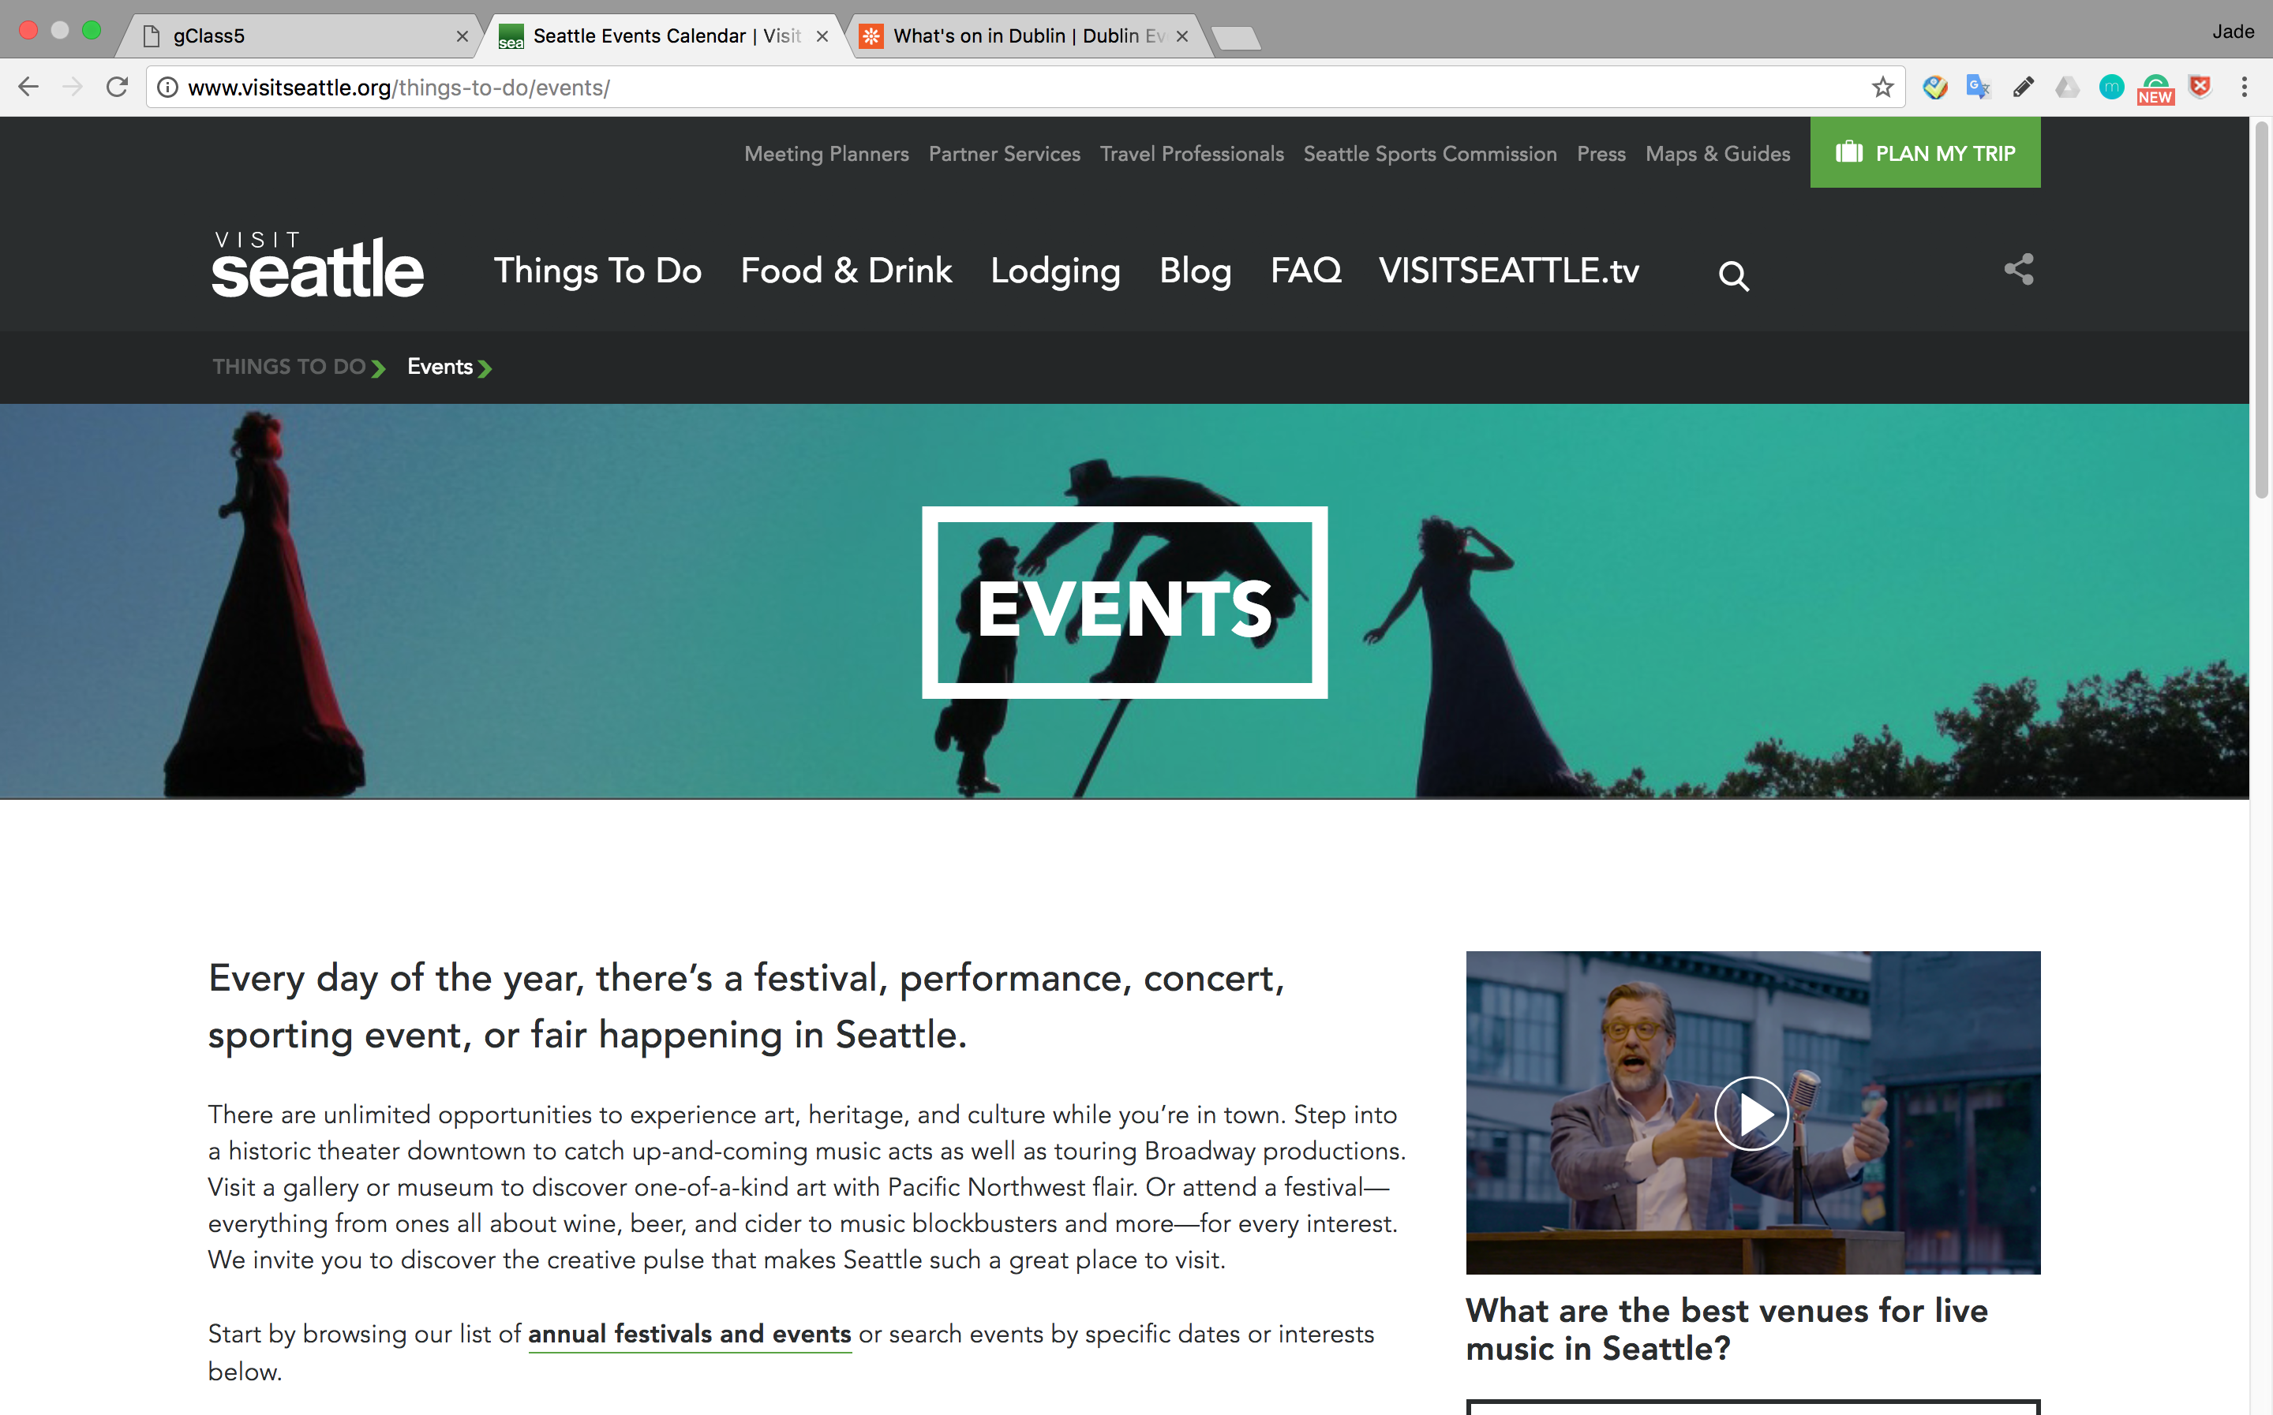

#### Pages (or Screens) look for the answerMacintosh HD:Users:Jade:Desktop:屏幕快照 2017-10-18 18.25.38.png

#### Page where you get an answerMacintosh HD:Users:Jade:Desktop:屏幕快照 2017-10-18 18.25.28.png

### Competitor 2 Pages

#### Page (or Screen) where you ask “What should I do tonight?”

<paste screen-shot here>

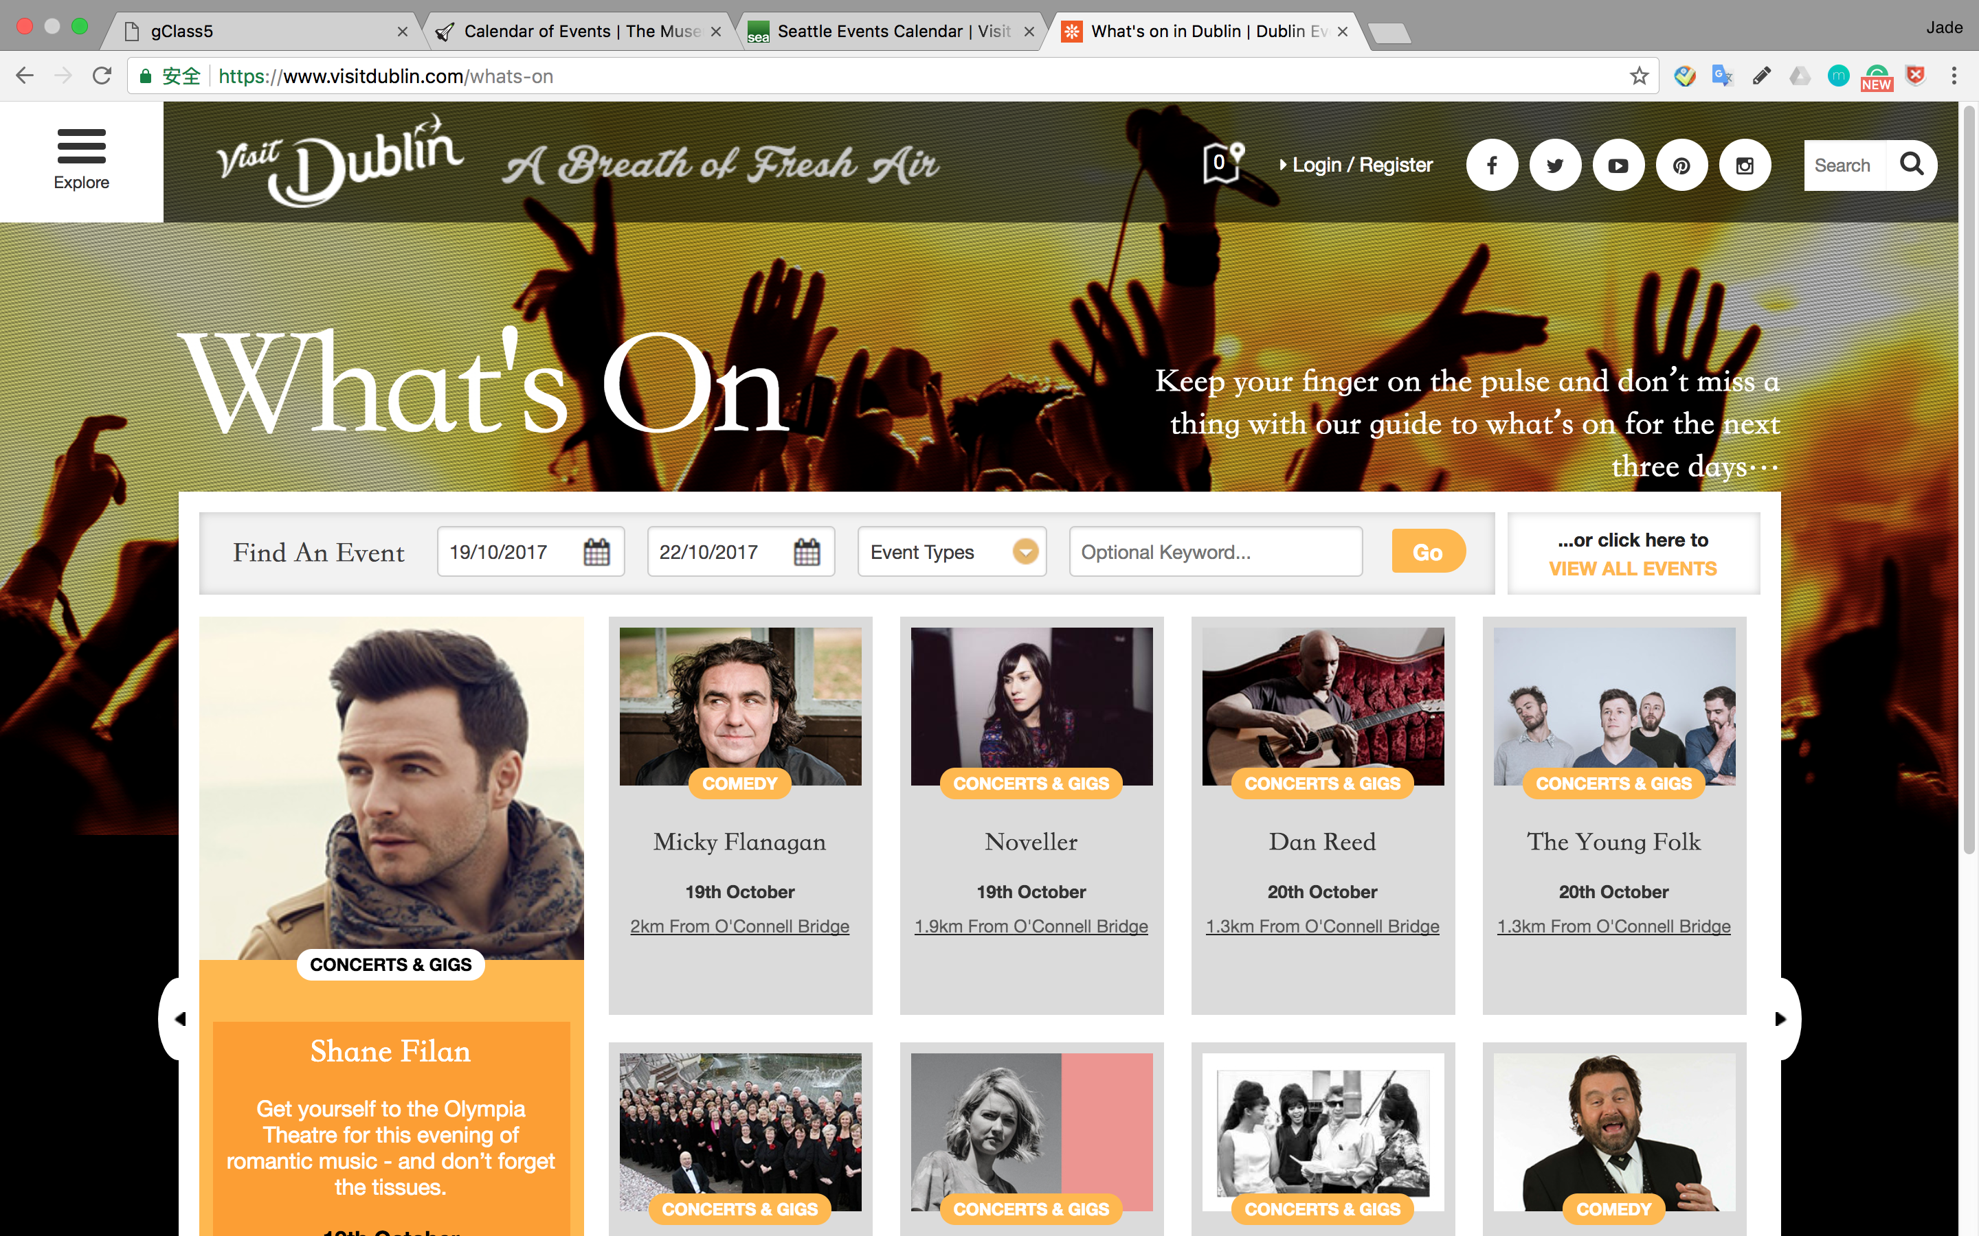

#### Pages (or Screens) look for the answer

<paste screen-shot here>

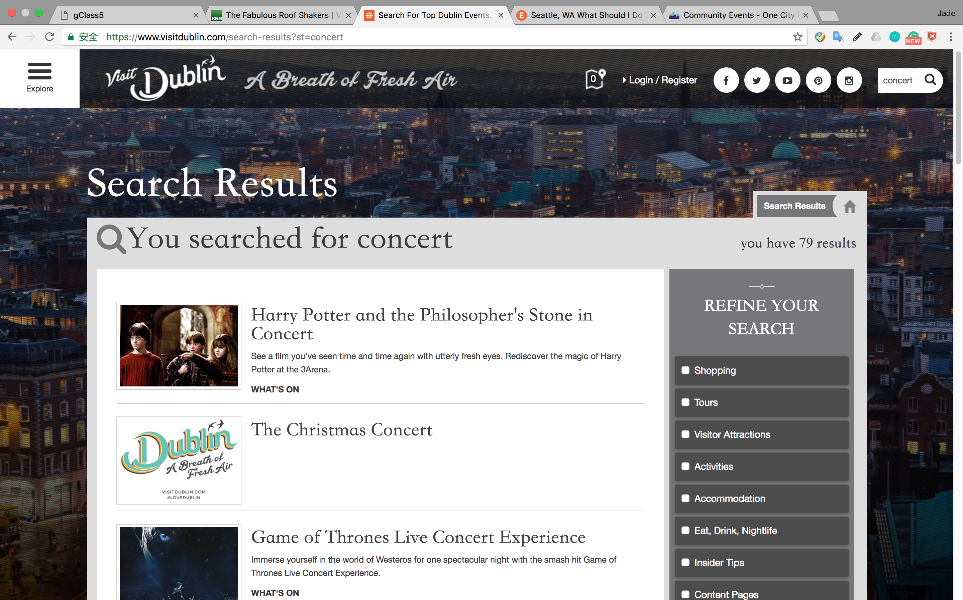

#### Page where you get an answer

<paste screen-shot here>

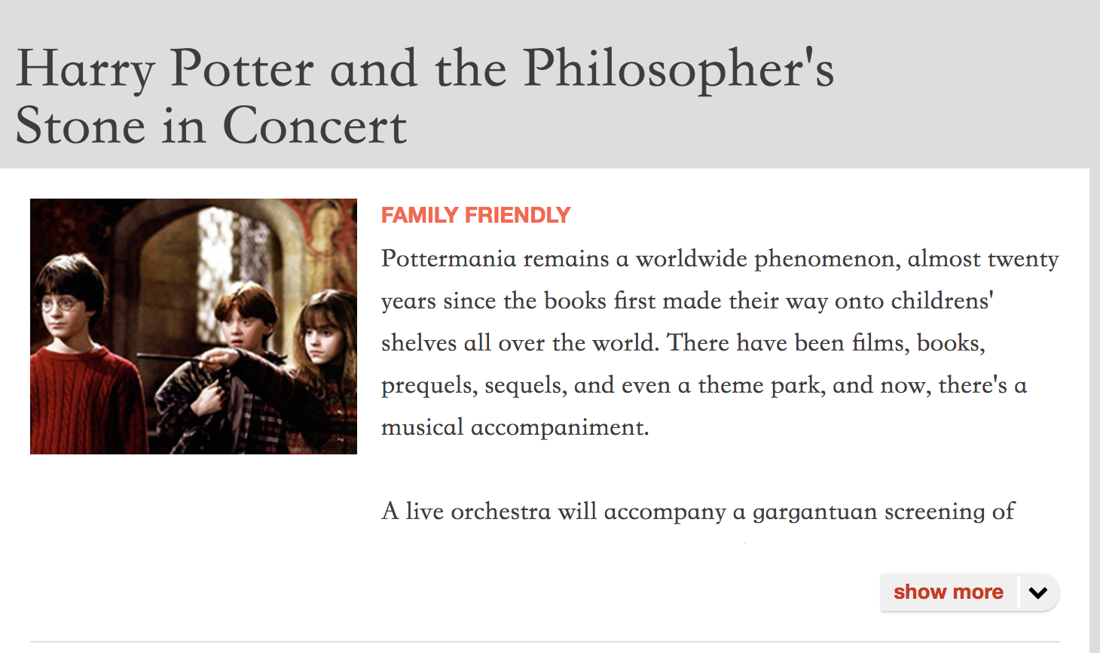

## Step 2: Sketch One Competitor Flow

### Favorite Competitor: Page Flow Sketch

Pages sketched as boxes for the flow between pages (or screens) where you ask “What should I do tonight?”, look for the answer, and get an answer. Arrows drawn between the boxes show how the pages are connected by clicks. Inside the page boxes details include:

* Where you ask the question
* Where the navigation is that allows you to find things to do
* Where the details of the “things to do” are displayed
* Where you click to move from page to page

<paste screenshot of sketches here>

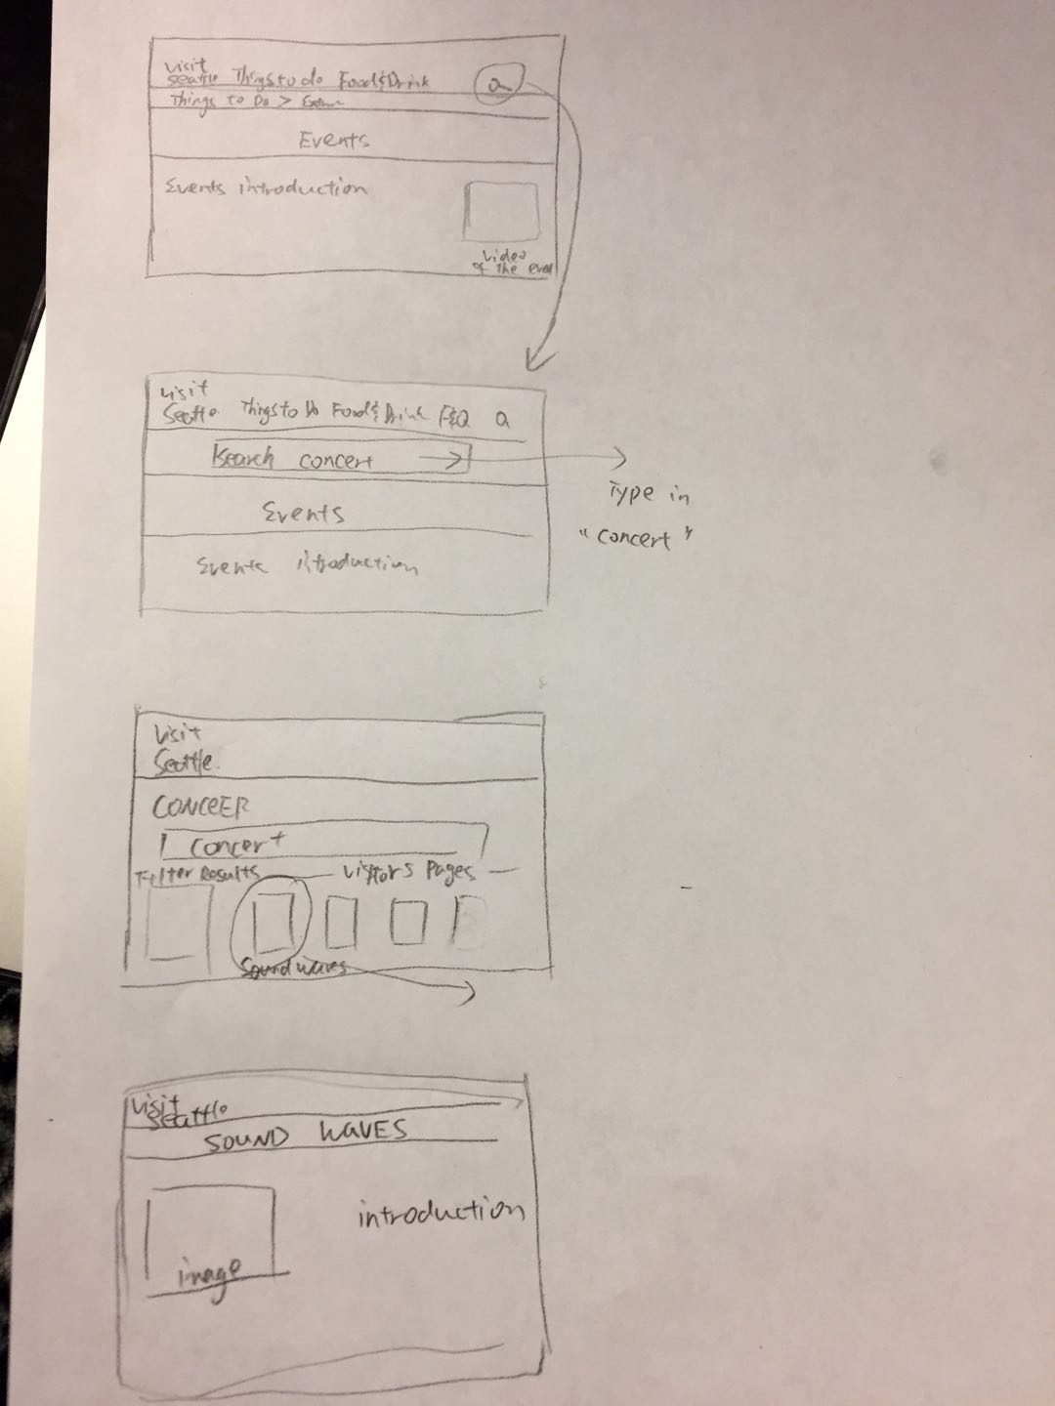

## Step 3: Sketch YOUR Flow

### My Site Name

<type the name of your site here>

#### Sketch of My Page Flow

Pages sketched as boxes for the flow between pages (or screens) where you ask “What should I do tonight?”, look for the answer, and get an answer. Arrows drawn between the boxes show how the pages are connected by clicks. Inside the page boxes details include:

* Where you ask the question
* Where the navigation is that allows you to find things to do
* Where the details of the “things to do” are displayed
* Where you click to move from page to page

<paste screenshot of sketches here>

